St John the Baptist

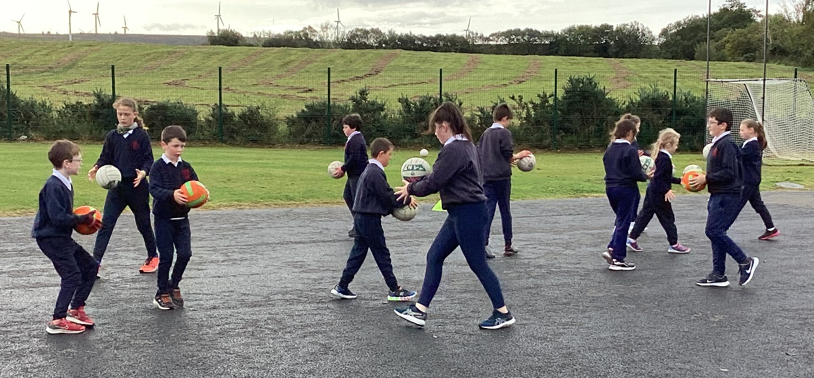
September2023
Welcome back everyone! We are well settled into our new school year by now and looking forward to our Halloween break.
School Calendar.
Halloween Break
Monday 30th October to Friday 3rd November
School Panto trip December
Christmas Holidays
Swimming after Christmas for whole school
Please continue to check the school website for updates. Miss Johnston updates it on a regular basis.
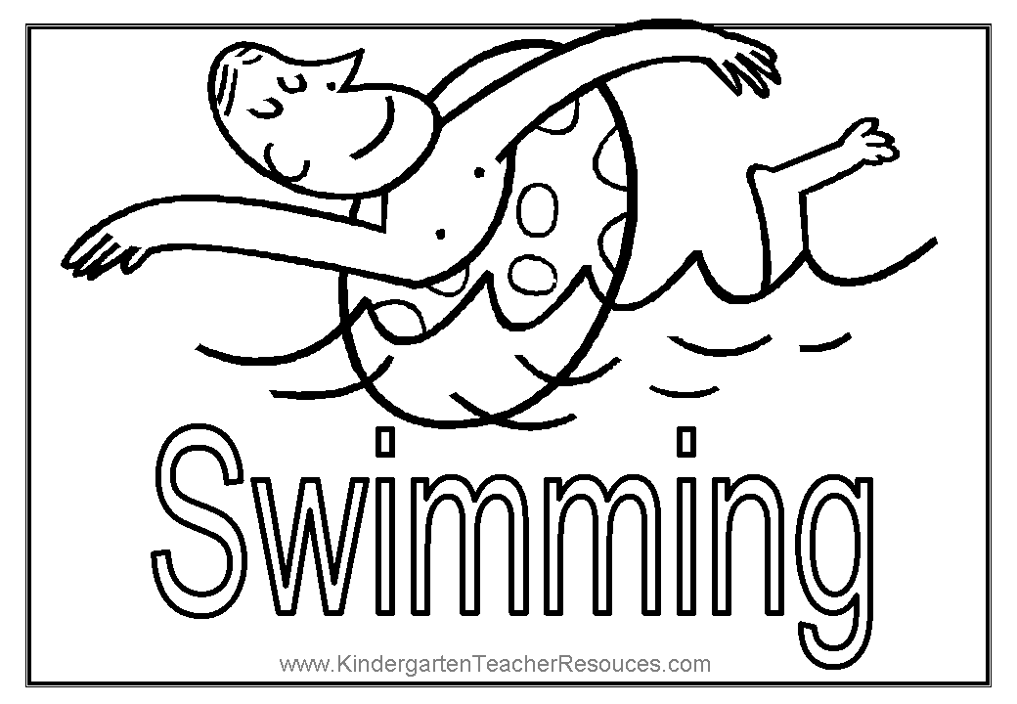
Swimming lessons for the whole school will start in January. Younger children will be encouraged to dry and dress themselves. This is a fantastic opportunity for the children to prefect or learn a very important life skill.
We would like to give a big welcome to Ms Meehan our new support teacher. We are very lucky to have this excellent resource.
Johnny is our new GAA coach. The P3 to P7 pupils are having training every Thursday. Johnny remarked on how well behave all the boys and girls are. They are all really enjoying the sessions.
Prayers for our school new year.
www.compassionuk-

Prayers for children’s protection
Take encouragement from the fact that our God is fully in control of all things, and we’re all a child of God! Remind yourself that “we know that in all things God works for the good of those who love him, who have been called according to his purpose.” Romans 8:28
Prayer: Lord God, we praise you that you are fully in control of all things. I pray you would protect my child/children. Keep them healthy and help them to thrive. I thank you that you know every hair on their head. You know exactly when they rise and when they fall. Watch over my child/children in every area of their life and keep them safe I pray, Amen.
As a close-knit community, we want to remember Ronan and Jamie’s Families and friends with their unimaginable pain. At school and home, we will keep them all in our prayers.

A PRAYER FOR STUDENTS
God we ask that you give them peace and courage as they begin a new year of classes
Surround them with supportive and encouraging friends. Bless their hard work over the coming months. Surprise them with unexpected moments of joy. Raise up this next generation of leaders and may they reflect Your love to those around them. Amen.

A PRAYER FOR TEACHERS & EDUCATORS
Thank you God for the men and women who invest in the future of our children. Give teachers and educators wisdom, creativity, and discernment as they lead others this year. Remind them that they are not alone and their work is not in vain. Move in close, Lord, and let them sense Your presence and Your delight. Amen.
A PRAYER FOR PARENTS OF STUDENTSAs change and transition begins to happen, calm any fears or anxieties. May Mums, dads, and guardians joyfully entrust their children into the hands of our loving God. Bless their family with a strong community. Give them Your peace, patience, and joy as they watch their student navigate a new school year. Amen.

Taken from Infogregholder.com
Paul from Water NI came to talk to us about where we get our fresh water supply from. How all water is recycled and cleaned for us to drink. We are received a free refillable water bottle.
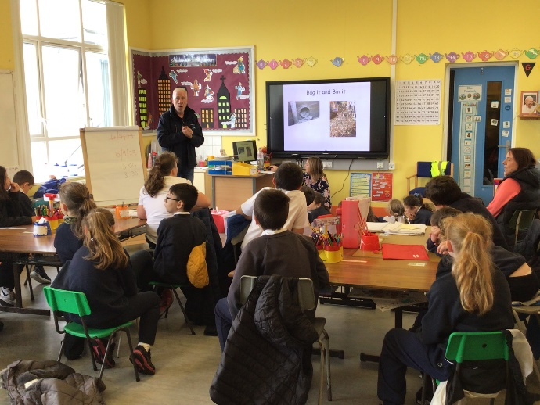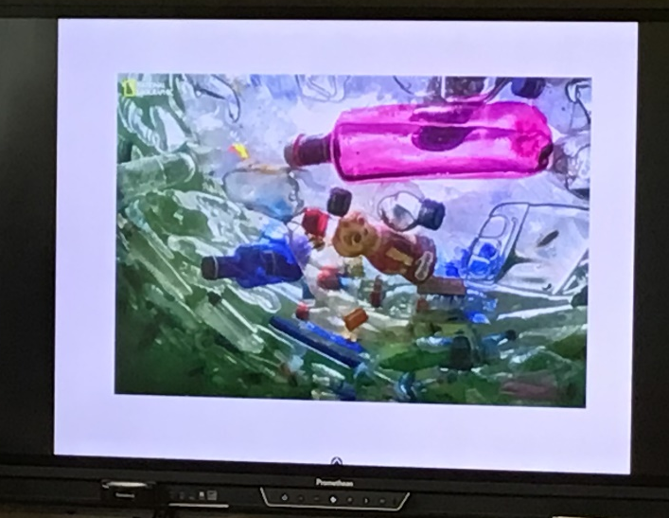
House Points
Carrenbeg 2030
Callagheen 2040
Laragan 1640
Corrakeel 1980

Congratulations Mr &Mrs McGovern
on the birth of your beautiful daughter April.

Most of you will know by now Miss Carney is
also acting principal in St Patricks Derrygonnelly.
As always if you need to contact school, please just phone
to arrange an appointment.
Please keep an eye on your child/ children’s seesaw account for important updates and information. Any notes sent here are never sent lightly and action should be taken if necessary. Thank you.

Dear Parents / Guardians.
It’s been a busy month already here at Roscor. We are starting to fill our calendar up with lots of activities and trips for the rest of this term. We have booked the pantomime in Derry for our annual day out and we have also added a wee trip to see “Little Miss Muffett” in the Ardhowen for Mrs Sinclair’s class.
I would like to invite you and your families to join us for our school mass on Thursday 12th October and come back to school for some refreshments after.
You may be aware that CCMS have placed me part time in St. Patrick’s Derrygonnelly as acting Principal. I will split my time equally between two schools. The arrangement is flexible and St. John the Baptist will be given more time when needed as these months go on. As part of this arrangement CCMS will pay for an additional teacher to work in our school to help support children who have additional needs. We are delighted to have Miss Imelda Meehan joining us to fulfil this role.
I am looking forward to catching up with everyone on Thursday.
Kind Regards
Tracy Carney.

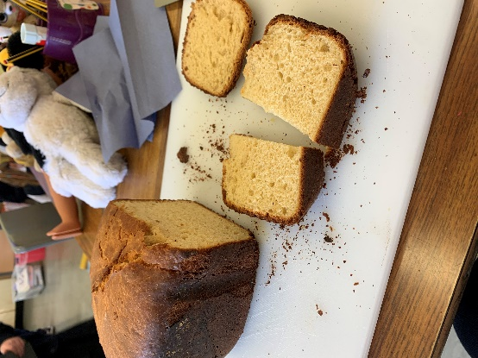
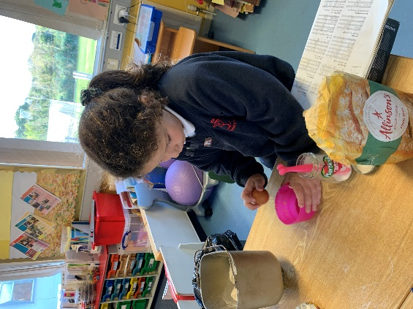
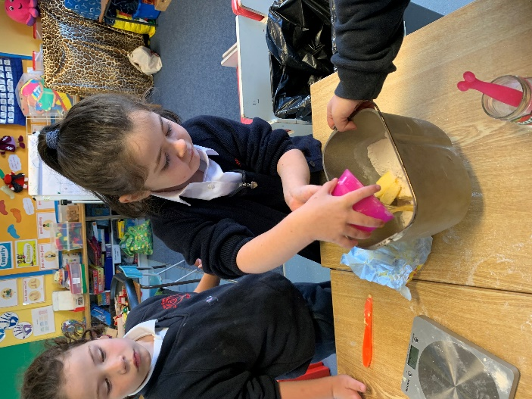
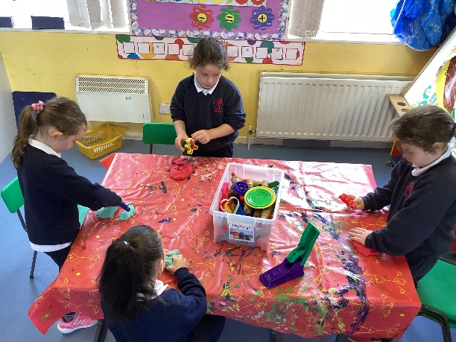
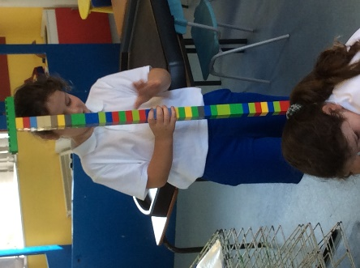

P2’s are a busy wee bunch!

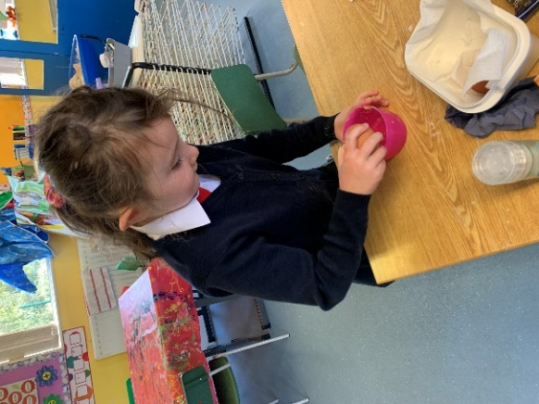
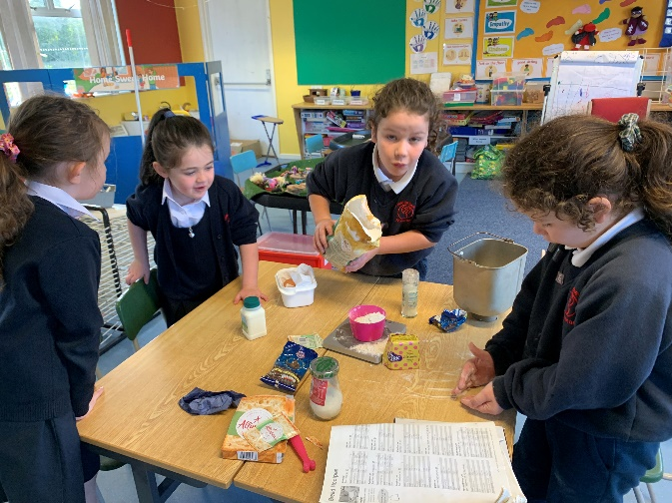

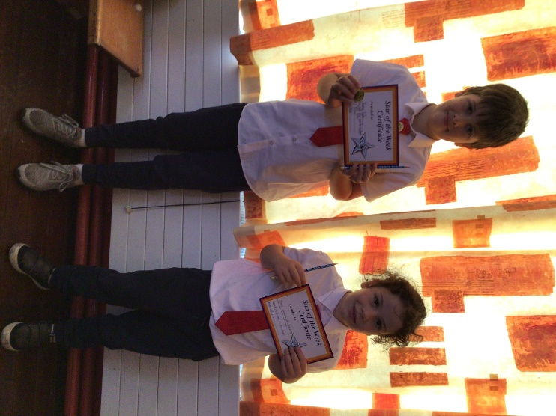
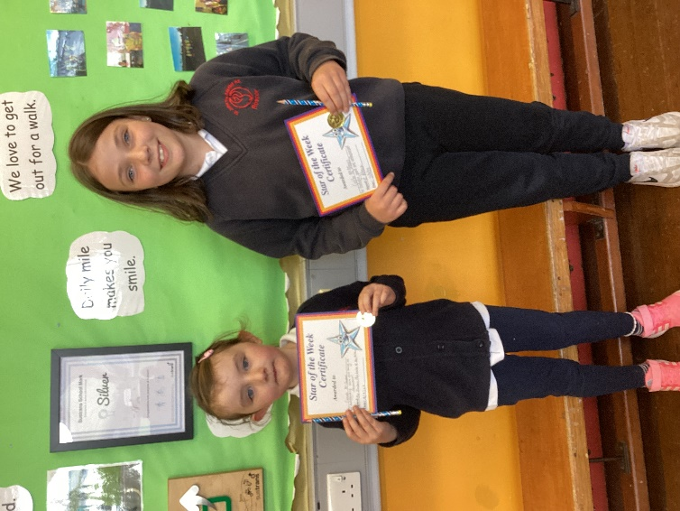
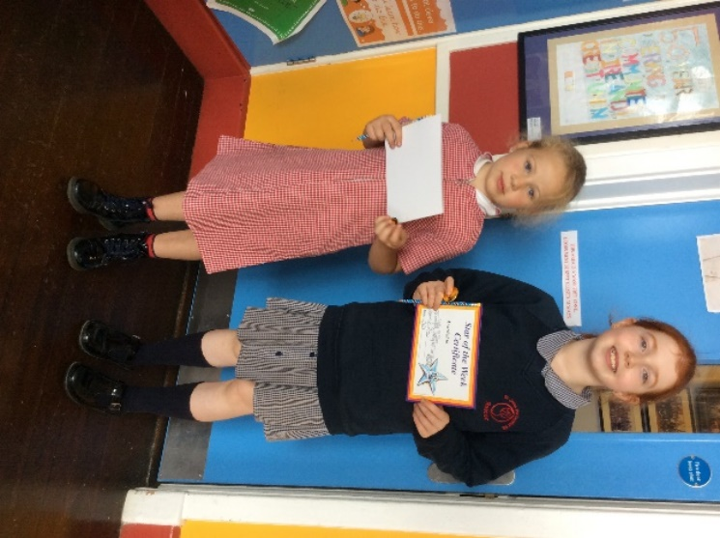
September Assembly

