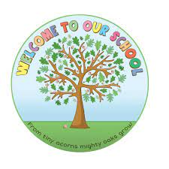****

Open to all prospective P1 pupils for September 2023.Parents and guardians are very welcome to view our fantastic school.

**St John the Baptist Primary School**

**Belleek**

***Open Day 2023!***

***Wednesday 11th January***

***1:30 TO 2:30 pm***

**Please contact school office on 02868658484**

**We look forward to meeting you!**